ISLES of SCILLY - 2011

26th Sept – 03rd Oct 2011
HIGHLIGHTS
Either for rarity value, excellent views or simply a group favourite.
- Pallid Harrier
- Solitary Sandpiper
- 3 Pectoral Sandpipers
- 4 Wrynecks
- Woodchat Shrike
- Honey Buzzard
- Mediterranean Gull
- Grey Seal
- Crimson Speckled
- Palpita vitrealis
- Northern Waterthrush
- Lesser Yellowlegs
- 4 Buff-breasted Sandpipers
- Firecrest
- 2 Short-toed Larks
- Black Kite
- Clouded Yellow
- Hummingbird Hawkmoth
- Hymenia recurvalis
- Old World Webworm

Leaders: Steve Bird & Gina Nichol
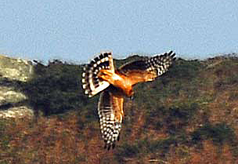
This juvenile Pallid Harrier gave us fantastic views as it hunted fields between New and old Grimsby, Tresco. Photo by Billy Quinn tour participant

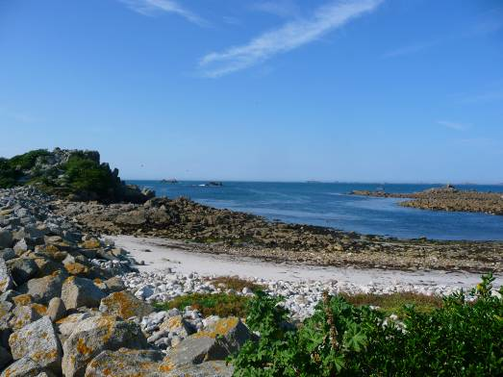
One of the islands many secluded and idyllic beaches

SUMMARY:
Autumn in the Isles of Scilly has long been a birding highlight of the year for many avid birders. Our trip during the last week of September into early October proved once again that these enchanted Isles can produce an enviable selection of vagrants. The weather this year was not ideal with fog set in for several days and little in the way of winds. Our accommodation got the thumbs up as it is one of the nicest houses on the island and an ideal base where one could easily take time out or relax after a full day birding. In fact the house is so nice that we were told we had even undersold it! See for yourself and join us in the best value trip to the fabulous Isles of Scilly.

26th Sept 2011
The first participants arrived on the Scillonian at mid-day and made their way up to our lovely accommodation overlooking the harbour at Hugh Town. Others arriving by air were delayed a little by fog but most had arrived by late in the afternoon.
For those that had arrived lunch-time we went out for an walk where we soon got familiar with many of the local birds. Common Starlings, House Sparrows, Barn Swallows, House Martins and Blackbirds were easily seen. Making our way to Old Town Churchyard we got views of several Linnets, Wrens and a confiding Song Thrush and Blackbird. A couple of Robins entertained us in an aggressive territorial dispute while more gentle Speckled Wood butterflies were taking advantage of the sunshine. In the nearby harbour we scanned the rocks and found both Greater and Lesser Black-backed Gulls, Herring Gull and a Gannets gracefully gliding by. Our first Grey Seal was spotted and we added Wood Pigeon, Chaffinch, Eurasian Collared Dove, Carrion Crow, White Wagtails and a fly over Grey Heron to our list. Returning to the house we met up with the late arrivals and enjoyed our first evenings glass of wine together.
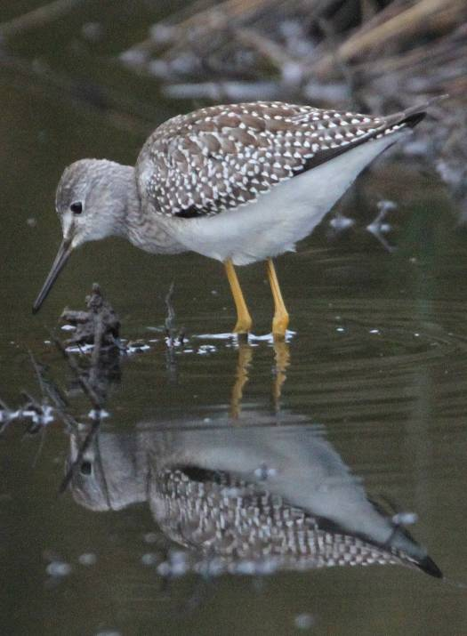
We all enjoyed excellent views of this Lesser Yellowlegs which was particularly close on a small pool and also seen on the nearby beach.
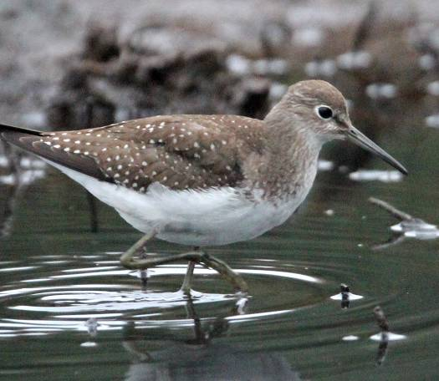
This Solitary Sandpiper also gave fantastic close views on the same pool!
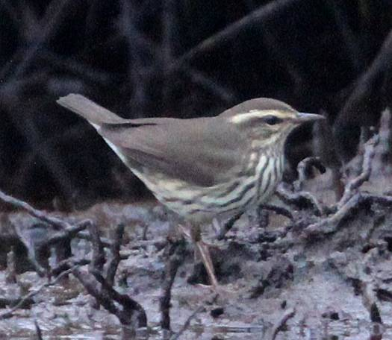
This rare Northern Waterthrush showed perfectly and was a trip highlight!

27th Sept 2011
Our mercury vapour light had attracted a few moths during the night and for those that were interested we recorded Setaceous Hebrew Character, Common Marbled Carpet, the Scilly Isles form of Lesser Yellow Underwing, L-Album Wainscott, Square-spot Rustic, Lunar Underwing and the scillonea sub species of Feathered Ranunculus. A nice looking Sexton Beetle was also caught. We all set off on a pre-breakfast walk to a new pool that had just been dug by an intrepid local birder! As we quietly waited for the morning light to brighten things up we could easily see a Lesser Yellowlegs strutting around just a few feet away totally unconcerned by our presence. Then if by magic a Solitary Sandpiper joined it and if this was not enough our third and rarest American vagrant also appeared in the form of a superb Northern Waterthrush. We enjoyed excellent views of all three for over twenty minutes before the Waterthrush chased a Grey Wagtail off returning briefly to give even better views, and then both the Solitary Sandpiper and Waterthrush flew off and disappeared into the back of the reed bed. Delighted with this we made our way towards Old Town where a check of the bay revealed Curlew, Cormorant, Oystercatchers, distant Gannets out on the water and a Kingfisher perched on a rock across the bay. We then returned for breakfast and awaited the arrival of Frank and Didi who had been delayed a day due to fog. With breakfast over and our moths released we set off through Hugh Town, pointing out and recommending several restaurants and eating establishments. A quick look along the tide line found Ruddy Turnstones, Oystercatchers, a Great Black-backed Gull with a crab, Herring Gulls and some Mallard. Making our way uphill toward the Garrison two Hummingbird Hawkmoths appeared and gave great views as they hovered around some garden flowers. We eventually totalled around six for the morning as well as numerous Speckled Wood butterflies, Red Admiral and a Small Copper. Further on overlooking Porthcressa Beach we managed to find Blue Tit, some tame Song Thrushes, Robin, Dunnock, Northern Wheatear and Carol spotted a leucistic Blackbird. While searching through the rocks we encountered more Wheatears, the first Black Redstart of the Autumn and several Rock and Meadow Pipits. Out on headland were a group of Shags and two distant Sandwich Terns flew past. Continuing on to the other side of the Garrison we enjoyed fabulous views of the other islands and being out of the wind we soon found Whimbrel, Great Tit, Stonechat and two Spotted Flycatchers spotted by Rick. We returned via town to the house for a short break and after lunch headed up towards the airfield. It was getting rather foggy but we managed to scope plenty of Northern Wheatears, White Wagtails and three Buff-breasted Sandpipers. Walking around one edge we also got great views of a female Woodchat Shrike that was first spotted perched in a bush and then later posed for us on the barb wire fence. With the fog thickening we headed back to the comfort of our house.
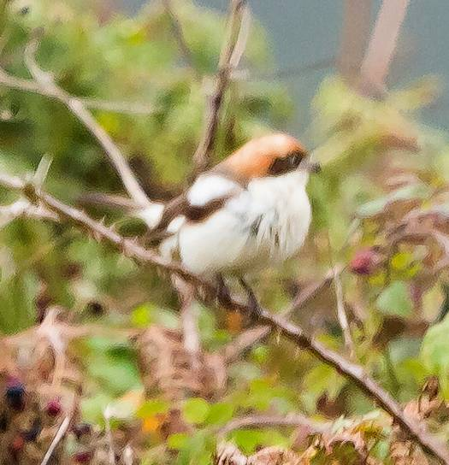
This Woodchat Shrike gave a good show on bushes and wires up near the airfield.
This photo was by Frank Hollis tour participant.
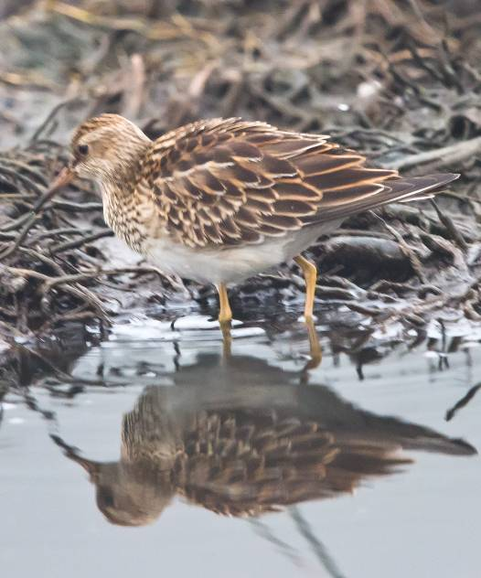
No Solitary Sandpiper this morning but instead Frank Hollis got this great photo of a Pectoral Sandpiper on the same tiny pool.
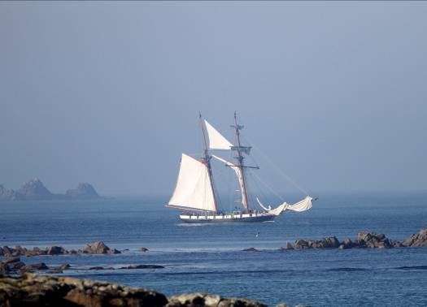
A reminder of the days of pirates as this tall ship sailed into Hugh Town!

28th Sept 2011
This morning’s moths included much the same as yesterday although we added Black Rustic, Dark Spectacle, Large Wainscott, Snout and Angleshades. We split our morning walk with Frank and Didi visiting the new pool and others taking a walk along Peninnis. The walkers found plenty of common birds and some Wheatears but were hampered by foggy conditions, while Frank and Didi got excellenft views of a Pectoral Sandpiper alongside the Lesser Yellowlegs. After breakfast we walked toward Porthmellon Beach where our search revealed plenty of White Wagtails and Common Starlings. Moving slowly on to Porth Thomas we scanned the beach and found several Ringed Plovers, a Grey Heron, Northern Wheatears, 40 plus Oystercatchers, two Sandwich Terns, Barn Swallows, Eurasian Collard Dove, Black-headed Gulls and a lone first winter Mediterranean Gull. Moving on we scoured the fields and bushes on the way to Telegraph. A couple of Common Kestrels were seen and a single Common Buzzard flew over. A circular walk produced very little except flocks of Goldfinch and Linnet so we made our way to Juliet’s Cafe for lunch. This was a beautiful setting overlooking the harbour and was made even more memorable by the tall ship that sailed in and the tame sparrows and Song Thrushes around our picnic tables. The weather was now hot and sunny and not really conducive to the arrival of any new migrants so we relax and enjoyed the view. Just as we were finishing up and ready to move on a Honey Buzzard was seen flying over the Garrison and out toward Tresco. A great way to finish lunch. Our afternoon walk took us through Watermill, Holy Vale and on to Porth Hellick. More Kestrels were seen, dozens of Wrens, a few Chiffchaffs, Blue Tit, Great Tit and from one of the hides we had Greenshank, Moorhens and Coot. We then crossed the edge of the beach and made our way along the coastal path toward the back of the airfield. Two Grey Seals were seen well and we spotted a Sparrowhawk, several confiding Wheatears, and the helice race of Clouded Yellow butterfly.
As Gannets fished along the coast we made our back to the house. A quick check of the new pool produced more fine views of the Lesser Yellowlegs.
29th Sept 2011
This morning’s moth count was very poor with no new species. We then walked to Peninnis along King Edward’s Road and witnessed a gorgeous sunrise. There was little in the way of new birds as we watched a pair of Kestrels hunting and a lone Whinchat perched up on a bramble. After breakfast we took a leisurely stroll through town to the dock where we took a boat to the small island of St. Agnes. A walk along the coastal path along Porth Killier produced many Oystercatchers, and more thorough searching amongst the seaweed covered rocks found us Grey Heron, Common Redshank, Ruddy Turnstones, Curlews, Ringed Plover, White Wagtails, Rock Pipits, Wheatear and even a Common Whitethroat. It was a stunningly beautiful day and with the exceptionally low tide many seldom seen rocks were now visible. As we savoured the view a harrier appeared silhouetted against the bright sky and promptly disappeared behind some cottages being chased by gulls. It was then seen through a gap where the white rump and dark inner underwing drew us toward Hen Harrier.
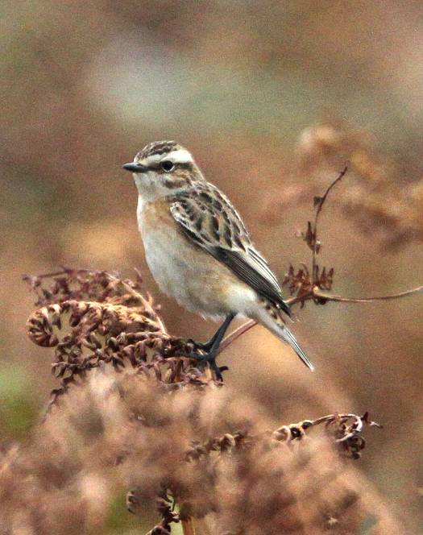
Whinchats were always nice to find and we managed a few around the islands.

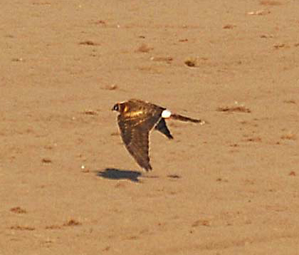
The Pallid Harrier was a major find on the islands and photographed by Billy Quinn tour participant.

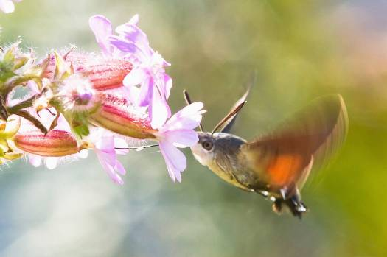
We had many sightings of the delightful Hummingbird Hawkmoth including a few that allowed photos such as this one by Frank Hollis tour participant

Hummingbird Hawkmoth

Lunch was taken at the famous Turks Head Inn overlooking the harbour and small island of Gugh. While sitting outside enjoying a fine lunch the harrier appeared again flying in front of Gugh before quartering the moorland above and then drifting out of sight. A nagging thought that the bird seemed too orange below for a Hen Harrier was soon dispelled when the news of a probable Pallid Harrier came through on the pager. Mentally kicking ones self I wish we had scoped it! News soon spread and it was indeed confirmed as a juvenile Pallid Harrier! Frank then got a message on his pager that a Short-toed Lark had been seen near the Big Pool so we left Annie and Judy to enjoy their chocolate brandy ice cream and went back along the coastal trail to find the seeded field where it had been seen.
We soon found a Common Skylark and a couple of Whinchats before another bird flew into the open field and showed well for several seconds enough to confirm that it was indeed the Short-toed Lark. A look at Franks photo also confirmed the salient features. Moving on we made our way through the centre of the island where we seemed to lose some of our group who had ice-cream on their minds! Wrong move as we then got details of a Wryneck seen nearby. We made our way down the lane to the right field and looked toward a dead tree where two birds flew up in quick succession – both Wrynecks! Amazing! It was time to catch our boat back to St Mary’s where we ended another super day.

30th Sept 2011
A little better for moths last night with numbers increasing and new species including Dark Spectacle, Dark Swordgrass and White-speck. Our early morning walk started off with two nice Hummingbird Hawkmoths feeding on a flowering bush just outside our gate. The walk along Peninnis was still a little quiet with Kestrels, a bunch of Meadow Pipits, Stonechat, Wheatears, Greenfinch and along the coastal path near Stony Porth we saw a Mediterranean Gull and then a brief Peregrine that flew by low and fast patrolling the coastline. Finishing off with a Grey Seal and the regular Gannets we headed back to the house. After breakfast we were just setting off for the morning when a call came over the radio that a Black Kite was flying over Porthloo towards the airport. We ran up the road to the highest point just in time to catch a glimpse of the bird before it disappeared in the distance. Continuing on to Porth Mellon beach we were pleased to see the Lesser Yellowlegs running along the shoreline, accompanied by White Wagtails and Rock Pipits. The nearby duck pond, held Moorhens among the mucky ducks and from there we made our way through Lower Moors. From one of the hides we were able to watch a Pectoral Sandpiper feeding along the waters edge while two Grey Herons flew over and a Chiffchaff flitted around outside. Moving on again we made our way to the Carreg Dhu garden where we found more Chiffchaffs and some very friendly Song Thrushes and Blackbirds feeding on the remnants of our snacks. We then worked our way around toward Juliet’s Cafe for lunch. A check of a small ploughed field produced Wheatear and Nicola spotted a Wryneck which allowed good views in the scope in front of a large roller! After our lunch stop we made our way to this little ploughed field and added a Common Redstart. Continuing up by the Golf Course and then on toward Halangy Down Settlement on the northwest coast of the island we found several Whinchats, a Whimbrel, distance juvenile Shag, a Cormorant in the water and large flocks of Linnets and Goldfinches. It was then time to head back along the coastal trail past Juliet’s and up the hill to the house.
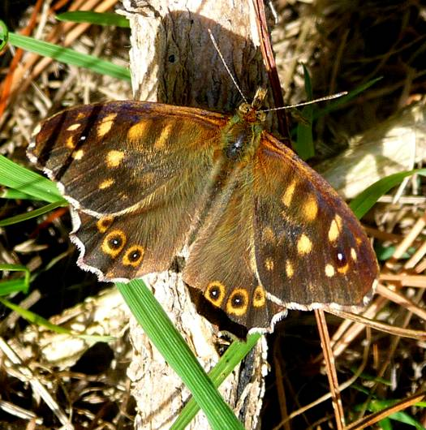
Speckled Wood butterflies were in abundance and seen just about everyday and everywhere. Photo by Gina Nichol
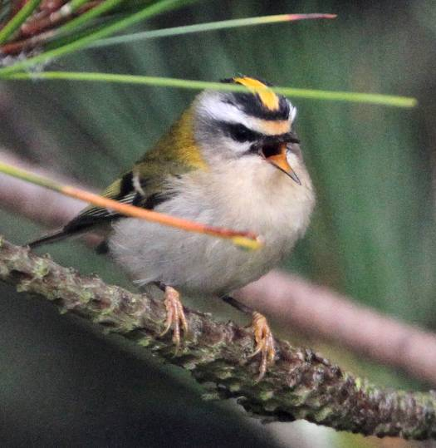
This showy Firecrest delighted us all on a misty morning on the Garrison.
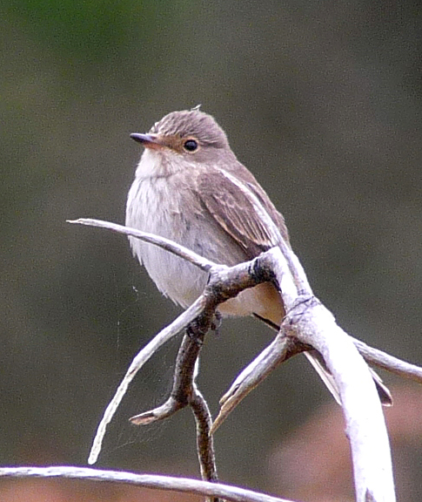
Spotted Flycatcher by Gina Nichol.

01st Oct 2011
This morning was very misty so we delayed our trip to Tresco and our early morning walk. The Rugby World Cup seemed to dominate our breakfast, but afterwards we made our way to the Garrison where a diligent search eventually produced fantastic views of Firecrest. A little further along and as the sun began to break through the mist we found a female Pied Flycatcher, Spotted Flycatcher and a lot of butterflies including Speckled Wood, Red Admiral, Clouded Yellow, Small Copper, Peacock, Comma plus a nice Hummingbird Hawkmoth perched. We took a short break for lunch and then in the afternoon we walked toward the airfield. At Old Town Beach there were Rock Pipits and Grey Heron and then we got a call on the radio to say the Black Kite was circling over Maypole and a look in that direction soon revealed the Kite flying around with a Common Buzzard and two Kestrels. The Black Kite then made its way toward us and eventually flew right over us at Old Town. The tide was exceptionally low allowing a few Oystercatchers good feeding. Nearby a Wryneck flew quickly off the track but never showed itself again. We continued our walk up the side of the airfield and once positioned we were able to scope four Buff-breasted Sandpipers running around the short grass. Amongst the odd Linnet and double figures of Wheatear we spotted a Short-toed Lark which allowed nice views and was even comparable to a Skylark that was close by. We moved on along the beautifully scenic coast path to Porth Hellick Bay which was also well drained due to low tide. Several Ringed Plovers, Ruddy Turnstones and a sleeping Dunlin were found before we entered the Higher Moors trail beside the Porth Hellick Pond. A Greenshank was seen from the hide but we were quickly pulled away when a report that the Pallid Harrier was flying nearby. We found an open area and scanned the skies but did not see it. As we came out of the Higher Moors nature trail and turned on to the main road leading back to Hugh Town we got superb views of the Black Kite perched up in a dead tree. A great way to finish the day.
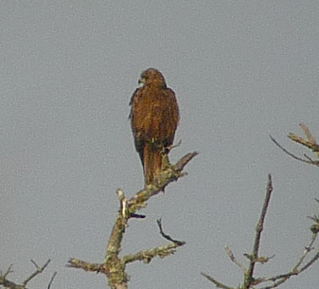
After getting flight views of this Black Kite it was nice to eventually see it perched up in a dead tree.
Photo digiscoped by Gina Nichol.
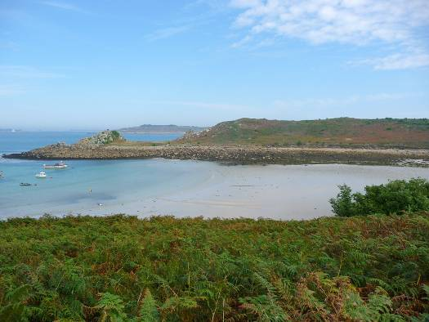
Another idyllic scene from these fabulous islands.
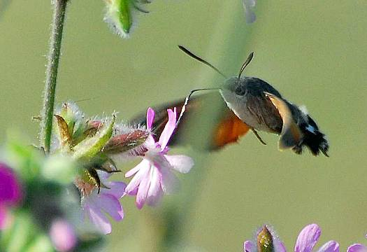
Another Hummingbird Hawkmoth, this time by Billy Quinn, tour participant
Billy’s photo of the Pallid Harrier

Pallid harrier

02nd Oct 2011
Last night had been our best night for moths and our light attracted over 20 species including 10 Large Wainscotts, 6 White-specks, 8 Silver Y moths, Rosy Rustic, Scarce Bordered Straw, and rare species such as 2 Old World Webworms and Rusty Dot Pearl. Our morning walk on Peninnis produced close views of Gannets fishing, and a female Common Redstart. We then had a leisurely breakfast before heading down to the quay and catching the first boat to the island of Tresco. On rocky island of Merrick just before we docked at New Grimsby we counted 16 Little Egrets. Once we were ashore we slowly made our way toward Old Grimsby. At Towns Hill, we stopped to survey an earthy field which had more birds in one place than we could keep track of. There were Whinchat, Spotted Flycatcher, Stonechat, Pheasant, male, female and young, feral Red-legged Partridge all over the place, Redstart, Blackbird and then Rick spotted a raptor flying across the hillside. It was the Pallid Harrier and it came towards us and coursed up and down showing all of its salient features. What fantastic views and lucky Billy had his camera as the rest of us had left ours behind! After the thrill of seeing this rare bird so well we made our along the coast to Block House Point where we overlooked a white sandy beach, surrounded by Caribbean blue water and several rock islands partially exposed by the falling tide. A Migrant Hawker dragonfly flew past, several Clouded Yellow butterflies were seen as well as Oystercatchers, Curlews, Sandwich Terns, Grey Heron and a Common Buzzard. Moving on to the Great Pool we saw three Greenshanks, several Moorhens and a female Teal. We then found a small wader on the far end of the pool which at distance had dark legs, and was putatively identified as a Little Stint. With Tresco Gardens and Cafe proving more attractive than our distant stint the group moved off. In hindsight we should have stayed behind and tried to get closer as a few days later after many people still reporting this bird as a Little Stint, it was found on the beach where its black legs were washed clean and showed yellow/green. Myself and Gina later returned to see a Least Sandpiper the first for Scilly in 49 years and indeed we have to say it looked like the same bird. Legs covered in black mud again, we got very close to it and could confirm all the features, although not obvious on this individual, and we agreed that this was probably the bird we saw! No more cafes for us! We then saw Kestrels, two Sparrowhawks and a Mute Swan on the far pond. After the lunch stop some of the group visited the gardens while the rest continued birding. We walked to the far end of the Great Pool and scoped the muddy edge. Coot, Gadwall, Mallard, Black-headed Gulls, Teal, Black-tailed Godwit, Lapwing, Dunlin, Greenshank, Redshank, a Water Rail and two Pectoral Sandpipers were our tally, and then we watched as two Common Buzzards rose above the woods and were joined by a Honey Buzzard which went to battle with one of the Common’s! A great finale to a great day. We return to St Mary’s and back to our house.
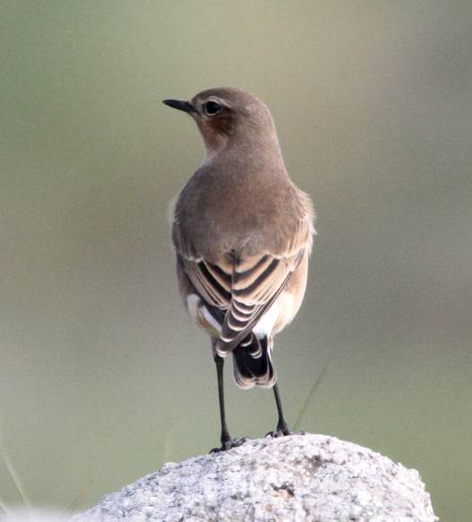
Wheatears were very common during the week with many seen along the coast or in fields and even on the airfield.

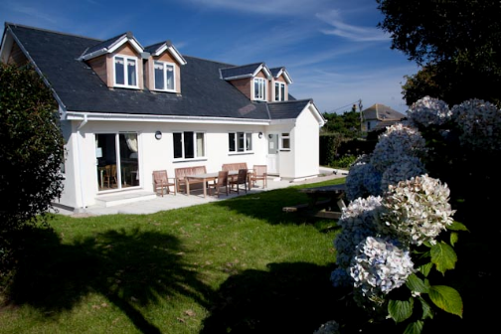Probably one of the nicest houses on St Mary’s and a delightful base for our tour. No other company can match this for quality or value for money.
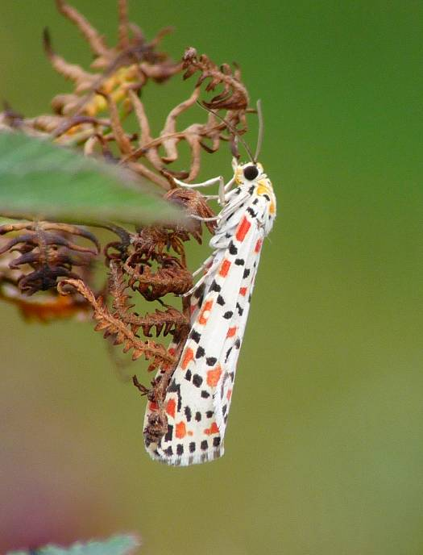
A day too late – Rare Crimson Speckled

03rd Sept 2011
Our last morning for some of our group to see what moths we had trapped. It was just getting better as we had even more than the night before and were into more rarities. Two Palpita vitrealis stole the show alongside Vestal, more Old World Webworms, Scarce Bordered Straw and Opogona omoscope. With different times of departure some of our group left on the first plane while others who were supposed to fly out later became victims of the fog and either had to depart on the Scillonian Ship or spend another night on the island. Rick & Carol were waiting around until 5pm before it was confirmed that their plane would not go. They did however get away first thing the following morning and even saw the two rarest moths of all in the form of a Crimson Speckled and a Hymenia recurvalis.

Myself and Gina would like to thank everyone that was on this tour as we had a marvellous time seeing the islands, many rare birds and a host of other wildlife. It was fun being with you all.

Steve & Gina

BIRDLIST FOR ISLES of SCILLY
Sept/Oct 2011

 | SPECIES | SCIENTIFIC NAME | Comments
 | Northern Gannet | Morus bassanus | Seen every day in passing any coastal area
 | Great Cormorant | Phalacrocorax carbo | Just a few individuals seen on 3 days
 | European Shag | Phalacrocorax aristotelis | Seen on 6 days with biggest flock of 150 from boat going to St Agnes.
 | Little Egret | Egretta garzetta | 16 birds seen on 1 day on Merrick Island just before docking on Tresco
 | Grey Heron | Ardea cinerea | Seen every day with a maximum of 3
 | Mute Swan | Cygnus olor | 10 seen flying into Great Pool Tresco
 | Canada Goose | Branta canadensis | Just 1 seen on Abbey pool fresco.
 | Gadwall | Anas strepera | 4 seen on Great Pool Tresco
 | Common Teal | Anas crecca | 4 seen on Great Pool Tresco
 | Common Buzzard | Buteo buteo | Singles seen twice on St Mary’s and 2 together on Tresco
 | Honey Buzzard | Pernis apivorus | One seen well fighting with Common Buzzard over Great Pool, Tresco
 | Mallard | Anas platyrhynchos | Seen in small numbers on 5 days
 | Pallid Harrier | Circus macrourus | A juvenile bird was seen briefly on St Agnes on the 29th Sept and then fantastic views on Tresco on the 02nd Oct
 | Eurasian Sparrowhawk | Accipiter nisus | Seen on 3 days with two seen on Tresco on the 02nd
 | Black Kite | Milvus migrans | A single bird was seen on 2 days with excellent looks perched on the 3rd
 | Common Kestrel | Falco tinnunculus | Seen on 4 days with highest daily count 4.
 | Peregrine Falcon | Falco peregrinus | Just 1 immature bird seen briefly flying along the shore on the 30th
 | Common Pheasant | Phasianus colchicus | Odd ones seen on 2 days
 | Water Rail | Rallus aquaticus | Heard on Lower Moors and 1 seen against reeds on Great Pool, Tresco
 | Common Moorhen | Gallinula chloropus | Seen on 5 days with maximum of 6
 | Eurasian Coot | Fulica atra | Small numbers seen on 3 days
 | Eurasian Oystercatcher | Haematopus ostralegus | Seen everyday with max count of over 100 on Tresco.
 | Common Ringed Plover | Charadrius hiaticula | Seen on 5 days with max 10 on St Agnes
 | Northern Lapwing | Vanellus vanellus | Just one seen on Great Pool, Tresco
 | Black-tailed Godwit | Limosa limosa | Two seen on Great Pool, Tresco
 | Eurasian Curlew | Numenius arquata | Seen on 5 days in small numbers
 | Whimbrel | Numenius phaeopus | 1 seen off the Garrison and another at Tolls Porth
 | Buff-breasted Sandpiper | Tryngites subruficollis | 4 were seen together on the airfield
 | Common Redshank | Tringa totanus | Just one on St Agnes and 10 on Great Pool, Tresco
 | Common Greenshank | Tringa nebularia | One seen at Porth Hellick, 12 on Tresco
 | Lesser Yellowlegs | Tringa flavipes | One seen very well on tiny pool, plus the same bird on Porth Mellon beach.
 | Solitary Sandpiper | Tringa solitaria | 1 seen very well on small pool near Dump
 | Ruddy Turnstone | Arenaria interpres | Seen everyday along shoreline and rocks
 | Dunlin | Calidris alpina | 1 seen at Porth Hellick and 6 seen on Great Pool, Tresco
 | Pectoral Sandpiper | Calidris melanotos | 1 seen close on small pool, 1 seen from hide on Lower Moors and 2 on Great Pool, Tresco
 | Least Sandpiper | Calidris minutilla | The bird we saw distantly as Little Stint on the 2nd was almost certainly this bird
 | Great Black-backed Gull | Larus marinus | Seen everyday
 | Herring Gull | Larus argentatus | Seen everyday
 | Lesser Black-backed Gull | Larus fuscus | Seen in small numbers on 5 days
 | Black-headed Gull | Larus ridibundus | Seen in small numbers on 5 days
 | Mediterranean Gull | Larus melanocephalus | 1st year birds were seen on 3 days
 | Sandwich Tern | Sterna sandvicensis | Seen on 3 days with max count of 5
 | Wood Pigeon | Columba palumbus | Common and seen everyday
 | Eurasian Collared Dove | Streptopelia decaocto | Common around town everyday
 | Eurasian Wryneck | Jynx torquilla | Seen on 3 days with 2 together on St Agnes and 2 singles on St Mary’s
 | Short-toed Lark | Calandrella brachydactyla | 1 seen on St Agnes and another showed well on airfield on St Mary’s
 | Eurasian Skylark | Alauda arvensis | Singles seen on St Agnes and St Mary’s
 | Barn Swallow | Hirundo rustica | Seen in small numbers everyday
 | House Martin | Delichon urbica | Just a couple seen on 2 days
 | Meadow Pipit | Anthus pratensis | Seen in small numbers everyday
 | Rock Pipit | Anthus petrosus | Seen in small numbers everyday
 | White Wagtail | Motacilla alba | Seen with max of 30+ everyday
 | Grey Wagtail | Motacilla cinerea | One joined Northern Waterthrush on small pool near dump.
 | Winter Wren | Troglodytes troglodytes | Common and seen everyday
 | Dunnock | Prunella modularis | Seen everyday
 | European Robin | Erithacus rubecula | Seen everyday
 | Black Redstart | Phoenicurus ochruros | Only one seen on rocks around Garrison on one day
 | Common Redstart | Phoenicurus phoenicurus | Females seen on just 2 days
 | Whinchat | Saxicola rubetra | Seen on 3 days with max count of 6
 | Common Stonechat | Saxicola torquata | Singles seen on 3 days
 | Northern Wheatear | Oenanthe oenanthe | Upwards of twenty seen everyday
 | Eurasian Blackbird | Turdus merula | Seen everyday
 | Song Thrush | Turdus philomelos | Seen everyday and very tame
 | Common Whitethroat | Sylvia communis | One seen on beach on St Agnes
 | Common Chiffchaff | Phylloscopus collybita | Seen on 4 days in small numbers
 | Firecrest | Regulus ignicapillus | Superb views of one bird found on the Garrison
 | Spotted Flycatcher | Muscicapa striata | Seen on four days with 2 at Garrison
 | Pied Flycatcher | Ficedula hypoleuca | 1 female seen well on the Garrison
 | Great Tit | Parus major | Seen in small numbers on 6 days
 | Blue Tit | Parus caeruleus | Seen in ones and twos on 4 days
 | Woodchat Shrike | Lanius senator | A female showed well up near the airfield
 | Carrion Crow | Corvus corone | Seen everyday
 | Raven | Corvus corax | Seen everyday
 | Common Starling | Sturnus vulgaris | Seen everyday
 | House Sparrow | Passer domesticus | Seen everyday
 | Chaffinch | Fringilla coelebs | Seen in small numbers on 5 days
 | European Greenfinch | Carduelis chloris | Seen in small numbers on 6 days
 | European Goldfinch | Carduelis carduelis | Small groups and flocks seen on 6 days
 | Eurasian Linnet | Carduelis cannabina | Small flocks seen everyday

 | Other Sightings | Scientific Name | Comments
1 | Rabbit | Oryctolagus cuniculus | Seen on a few days with the odd Black ones seen
2 | Grey Seal | Halichoerus grypus | Up to 2 seen on 3 days
3 | Sexton Beetle | Nicrophorus sp | 1 found attracted to moth light
 | Butterflies
1 | Red Admiral | Vanessa atalanta | Lots seen throughout trip
2 | Comma | Polygonia c-album | Two seen
3 | Clouded Yellow | Colias croceus | We saw about 6 or 7
4 | Clouded Yellow (Helice) | Colias croceus helice | One of this pale form seen at airport
5 | Speckled Wood | Pararge aegeria | Common and saw many almost everyday
6 | Peacock | Inachis io | Just 3 or 4 seen
7 | Small Copper | Lycaena phlaeas | About 3 or 4 seen
8 | Large White | Pieris brassicae | Seen in small numbers most days
 | Moths
9 | Hummingbird Hawkmoth | Macroglossum stellatarum | This spectacular species was seen on 5 days with a maximum of 6 on the Garrison
10 | Setaceous Hebrew Character |  | About 30 trapped at light
11 | Common Marbled Carpet |  | Just 2 trapped at light
12 | Lesser Yellow Underwing |  | About 12 trapped and all of the Scilly Isles form
13 | Large Yellow underwing |  | About 30 trapped at light
14 | Lunar Underwing |  | About 18 trapped at light
15 | L-Album Wainscott |  | About 28 trapped at light
16 | Square-spot Rustic |  | 7 trapped at light
17 | Feathered Ranunculus |  | About 15 of the form scillonia trapped
18 | Dark Spectacle |  | Just 2 trapped at light
19 | Black Rustic |  | About 45 trapped at light
20 | Large Wainscott |  | About 18 trapped at light
21 | Snout |  | About 10 trapped at light
22 | Angleshades |  | About 12 trapped at light
23 | Dark Swordgrass |  | 4 trapped at light
24 | White-speck |  | About 15 trapped at light - immigrant
25 | Silver Y moth |  | About 20 in trap and others during daytime in and around bracken
26 | Yellow-tail |  | Just 2 trapped at light
27 | Common Wainscott |  | 2 trapped at light
28 | Scarce Bordered Straw |  | 3 trapped at light - immigrant
29 | Turnip Moth |  | 4 trapped at light
30 | Rosy Rustic |  | 1 trapped at light
31 | Willow Beauty |  | 2 trapped at light
32 | Garden Carpet |  | 1 trapped at light
33 | Vestal |  | 4 trapped at light - immigrant
34 | Light Brown Apple Moth |  | 3 trapped at light
35 | Old World Webworm |  | 6 trapped at light – rare immigrant
36 | Rusty Dot Pearl |  | 9 trapped at light - immigrant
37 | Palpita vitrealis |  | 2 trapped at light – rare immigrant
38 | Opogona omoscope |  | 3 trapped at light – rare immigrant
39 | Eudonia angustea |  | 2 trapped at light - immigrant
40 | Hymenia recurvalis |  | 1 trapped at light – very rare immigrant
41 | Crimson Speckled |  | 1 trapped at light and another during day – very rare immigrant
42 | Dragonflies
43 | Migrant Hawker |  | Two seen flying around on Tresco
44 | Common Darter |  | One seen perched on wall on Tresco

